Zombie Escape!



You are trapped in a huge hotel that has been overrun by zombies!

To help you escape, you have a small remote-controlled robot.

There’s no point trying to use it to memorize where the zombies are – there are too many rooms and too many zombies, and they’re all moving around the hotel too much anyway.

You need to make your robot learn.

You need to train your robot to learn the way the zombies behave, and what sort of places the zombies seem to like. Train your robot to learn which hotel rooms are more likely to be safe, and which rooms you should avoid.

Once you’ve trained it, you can use the predictions it makes to guide you to safety.

Your mission is to escape the zombies.

Good luck!

This project worksheet is licensed under a Creative Commons Attribution Non-Commercial Share-Alike License

http://creativecommons.org/licenses/by-nc-sa/4.0/

You will use your robot to search the hotel.

Your robot is a bit like a robot vacuum cleaner, except it has space for **five special sensors** on top.

The sensors can find out lots of information about the rooms from the corridor outside. Unfortunately, they can’t detect zombies!

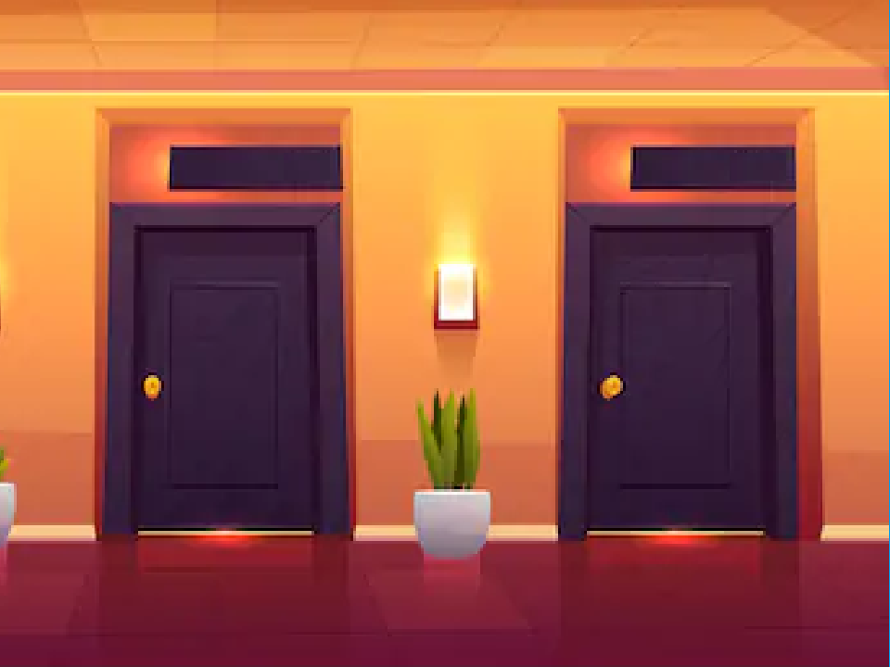You will use your robot to detect all the information it can about rooms from outside.

Then it will go inside to check if there are zombies in there.

This will let you train the robot to predict if a room has zombies in without having to go in.

Your first job is to **choose what sensors** you will fit to your robot.

Your robot has space for five sensors. You have twelve sensors to choose from.

The sensors you have to choose from are listed on the next page.

Some of them might be very useful. Some of them might not be.

**What information do you think will be the most useful to your robot to predict whether there is a zombie lurking behind each door?**

Try to choose a different set of sensors from your classmates. That way you will be able to compare the difference it makes in how good your robots are at making predictions!

|  |  |
| --- | --- |
| **Lighting type**  This sensor will tell you the type of lighting in the room – e.g. fluorescent tube, or halogen bulb. | **Humidity**  This sensor will tell you how damp the room is, by measuring the humidity percentage in the room. |
| **Temperature**  This sensor will tell you the temperature in the room in °Celsius. | **Wall colour**  This sensor will tell you what colour the walls in the room are. |
| **Floor type**  This sensor will tell you what the floor is covered with – e.g. carpet. | **Number of chairs**  This sensor will tell you how many chairs are in the room. |
| **Room size**  This sensor will tell you how big the room is, by measuring the floor space in square metres. | **Number of windows**  This sensor will tell you the number of windows in the room. |
| **Brightness**  This sensor will tell you how bright the room is in lux. | **Noise level**  This sensor will tell you how noisy the room is in decibels. |
| **Number of mirrors**  This sensor will tell you the number of mirrors in the room. | **Room number**  This sensor can read the room number from the room door. |

1. Go to <https://machinelearningforkids.co.uk/> in a web browser
2. Click on “**Get started**”
3. Click on “**Log In**” and type in your username and password  
   *If you don’t have a username, ask your teacher or group leader to create one for you.  
   If you can’t remember your username or password, ask your teacher or group leader to reset it for you.*

1. Click on “**Projects**” on the top menu bar
2. Click the **“+ Add a new project**” button.
3. Name your project “Zombie Escape” and set it to learn how to recognise “**numbers**”.   
   
4. Use the “**Add a value**” button to add a value for each of the **five** sensors you have chosen for your robot.  
   *See the next page for examples.*

|  |  |
| --- | --- |
| If you have chosen the **lighting type** sensor, add this.  It should be **multiple-choice** with the options **NONE**, **HALIDE**, **HALOGEN**, **INCANDESC** (for “incandescent bulbs”), and **FLUOURESC** (for “fluorescent tubes”) | If you have chosen the **humidity** sensor, add this: |
| If you have chosen the **temperature** sensor, add this: | If you have chosen the **wall colour** sensor, add this.  It should be **multiple-choice** with the options **BLACK**, **BROWN**, **GRAY**, **WHITE**, **YELLOW** |
| If you have chosen the **floor type** sensor, add this.  It should be **multiple-choice** with the options **CARPET**, **LAMINATE**, **STONE**, **TILES**, **WOOD** | If you have chosen the **number of chairs** sensor, add this: |
| If you have chosen the **room size** sensor, add this: | If you have chosen the **number of windows** sensor, add this: |
| If you have chosen the **brightness** sensor, add this: | If you have chosen the **noise level** sensor, add this: |
| If you have chosen the **number of mirrors** sensor, add this: | If you have chosen the **room number** sensor, add this: |

1. When you have chosen your **five** sensors, your screen should look something like this.   
   Click “**Create**”.   
   A screenshot of a cell phone

   Description automatically generated
2. **Zombie Escape** should show up in your list of projects. Click on it.  
   A screenshot of a cell phone

   Description automatically generated
3. Click “**Train**”  
   A screenshot of a cell phone

   Description automatically generated
4. Use the “**+ Add new label**” button to add two buckets:   
   “**safe**” and “**zombie**”.   
   *These will be* *where you’ll store information about rooms that your robot encounters: sensor information about the safe rooms in the left bucket, sensor information about the rooms with zombies in in the right bucket.*   
   A screenshot of a cell phone

   Description automatically generated
5. Click on the “**< Back to project**” link in the top-left.
6. Click the “**Make**” button  
   A screenshot of a cell phone

   Description automatically generated
7. Click on “**Scratch 3**”  
   A screenshot of a social media post

   Description automatically generated
8. Click on “**straight into Scratch**”.  
   *The page will warn that you haven’t trained a machine learning model yet, but that’s okay – you will use Scratch to collect your training data.*
9. Click on “**Project templates**” in the top menu.   
   A screenshot of a cell phone

   Description automatically generated
10. Click on the **Zombie Escape** project template. A screenshot of a computer

    Description automatically generated
11. Start by trying out the project.  
    Click on the **full-screen** button and then the **Green Flag**.   
    A screenshot of a cell phone

    Description automatically generated

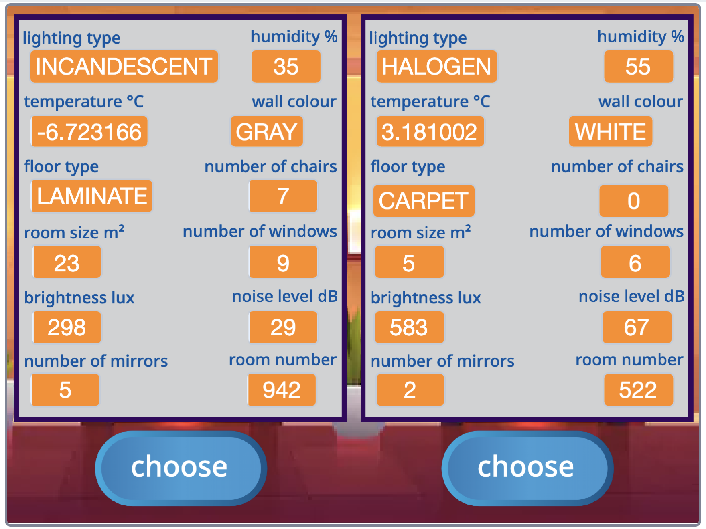  
Click the **Train** button in the project.  
  
Each time your robot reaches the doors for the next two rooms, it will display it’s sensor readings.  
  
Choose the room you think is probably the safest.  
  
  
  
If you choose correctly, your robot will move on to the next corridor.

If you make the wrong choice, you’ll see a zombie!  
  
When you think you understand, it’s time to train your robot!

1. Click the “**welcome**” sprite and find these pink **define** blocks.  
   A screenshot of a computer

   Description automatically generated
2. Find the **define predictions** script, and drag in the blocks with the names of your two training buckets into the script.  
   A screenshot of a cell phone

   Description automatically generated
3. **If you chose the lighting type sensor**, find the **define lighting types** script, and drag in the blocks with the names you gave for the multiple-choice options for lighting types.  
   *If you didn’t choose the lighting type sensor, you should skip this step.*  
   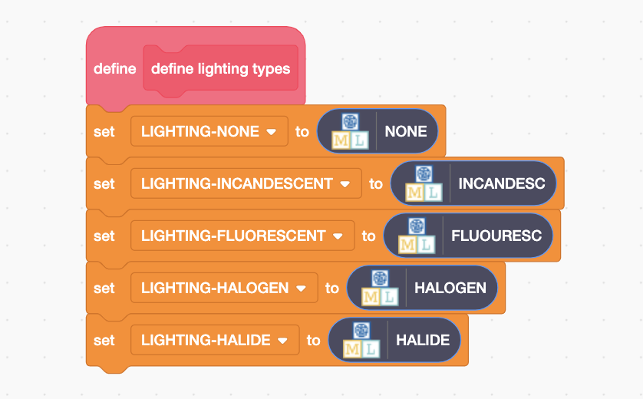
4. **If you chose the wall colour sensor**, find the **define colour names** script, and drag in the blocks with the names you gave for the multiple-choice options for colours.  
   *If you didn’t choose the wall colour sensor, you should skip this step.  
   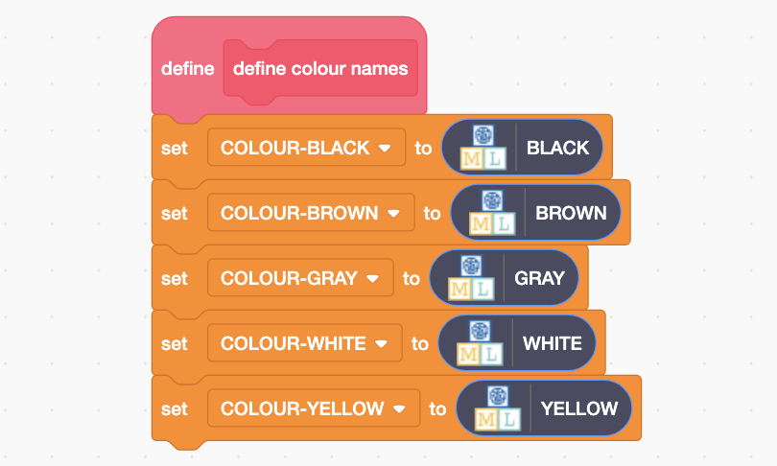*
5. **If you chose the flooring types sensor**, find the **define floor types** script, and drag in the blocks with the names you gave for the multiple-choice options for flooring.  
   *If you didn’t choose the flooring types sensor, you should skip this step.*   
   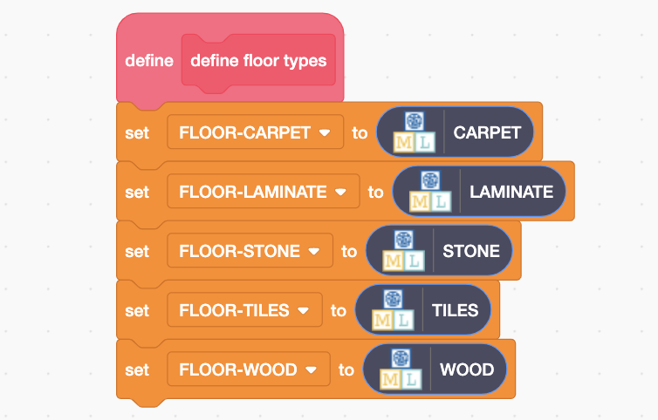
6. Find the **when I receive new-rooms-info block**.   
   *You**don’t need to drag it – it is all ready for you, as shown below.*   
   *This is still on the* ***welcome*** *sprite.*  
   A screenshot of a computer

   Description automatically generated
7. Drag an **add training data** block and add it to the event.  
   *The values listed on your add-training-data block will be the sensors you chose for your robot.*   
   A screenshot of a cell phone

   Description automatically generated
8. Drag **state – room1** into the last space on the block  
   *You’ll find it just underneath, all ready for you!*  
   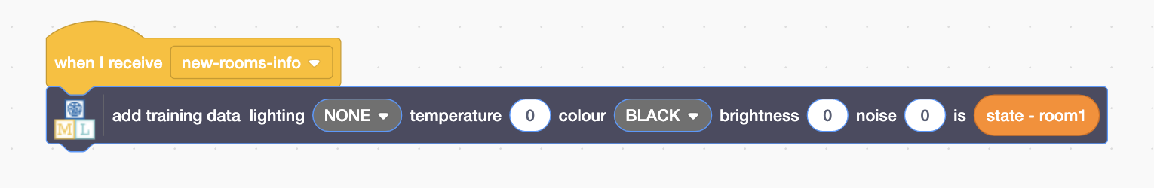
9. 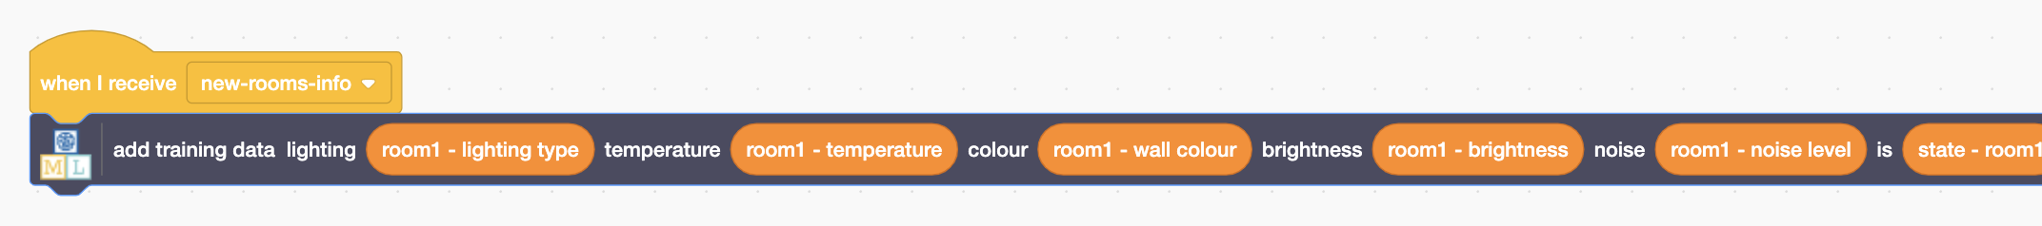Fill the rest of the spaces in the block with **room1** values.  
   *The values you need to drag in are the sensors you’ve chosen.   
   Just match the names.   
   You’ll find the blocks you need in the group underneath, all ready for you.  
   Make sure you use* ***room1*** *(not room2) values for this block.*
10. Drag another **add training data** block and add it underneath.   
    Drag **state – room2** into the last space in this new block, similar to before.  
    A screenshot of a cell phone

    Description automatically generated
11. Fill the rest of the spaces with **room2** values, similar to before.   
    *The blocks you need are just below – you only need to choose the ones for the sensors that you have chosen.*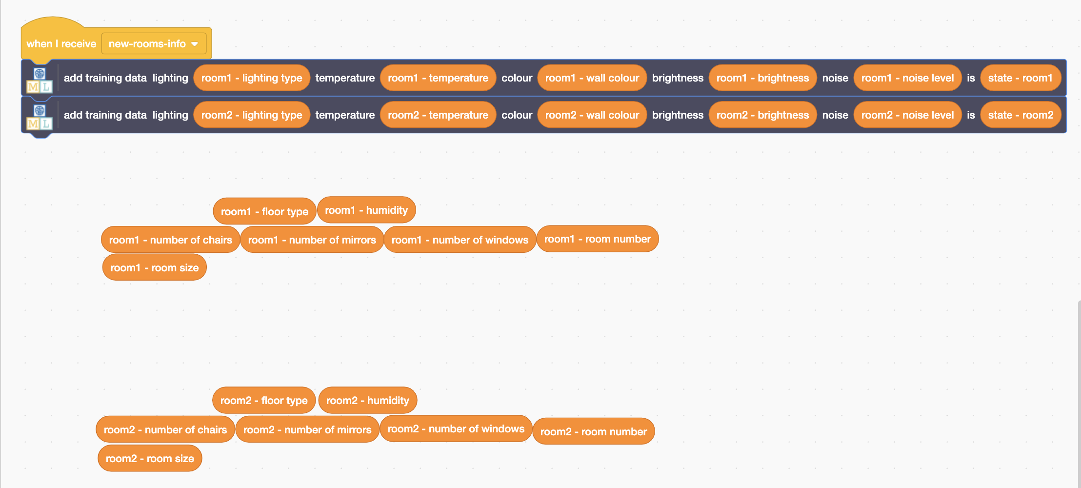
12. It’s time to start training your robot!  
    Click on the **Green Flag** and then click **Train**.   
    A screenshot of a computer

    Description automatically generated  
      
    *As your robot reaches new rooms, your script will add these experiences to the robot’s training data.   
    You will be using these to train a machine learning model.*A screenshot of a cell phone

    Description automatically generated *As you control your robot, try to look for patterns in the sensor data.****Can you tell what sort of rooms seem to be safest, and which seem to have zombies in?***

**What have you done so far?**

You started by choosing the sensors to use to train your robot. In machine learning, this is called “**feature selection**” because you’re selecting the features you want your model to look for patterns in.

Some of the sensors you could choose from have no impact on whether a zombie is in the room.

Machine learning techniques can cope with this. If you chose sensors that aren’t useful, your machine learning model should learn that these aren’t useful. It should learn to ignore them. It means this won’t stop your project working (as long as you’ve chosen **some** that are useful!)

Feature selection is still helpful, because having more features makes your code more complicated and makes training take longer.

1. When you think you’ve got enough training examples to try your escape, go back to your project **Code** for the **welcome** sprite and find the next group of blocks below.  
   A screenshot of a computer

   Description automatically generated
2. Join the groups together, then drag “**recognise numbers … (label)**” blocks into the spaces.  
   *The values on the block will be the sensors you chose.*  
   *Make sure you pick the (label) block,* ***not*** *the (confidence) one.*  
   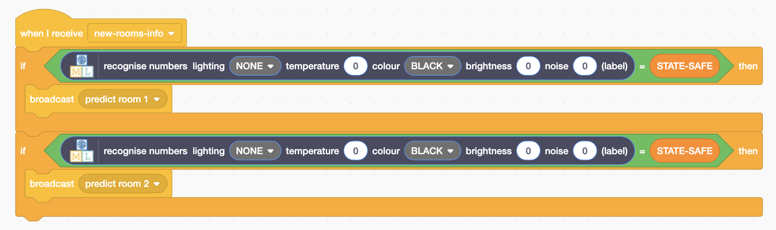
3. Copy the room values into the **recognise numbers** block, as shown.  
   - The blocks you need are below ready for you  
   - Choose the blocks to use by matching up the sensor names  
   - You only need to use the ones for the sensors you’ve chosen  
   ***Make sure*** *you put* ***room1*** *values in the block with* ***predict room 1****,   
   and put* ***room2*** *values in the block with* ***predict room 2****.  
   A screenshot of a computer

   Description automatically generated*
4. Create this final new script   
   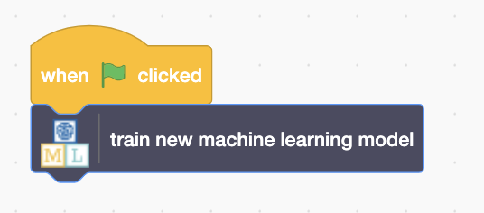
5. Escape time! Click the full-screen and Green Flag buttons again, then click on the **Escape!** Button in the project.
6. Your machine learning model will use what it has learned to predict which room should be safe. Try taking this advice and use that to escape.  
   *If the machine learning model thinks a room should be safe, the “choose” button will be highlighted in green.*  
   A screenshot of a cell phone

   Description automatically generated

**What have you done so far?**

You have made a “**predictive model**” that is giving you advice.

The machine learning model isn’t in charge, and it’s not replacing you. It’s giving you a recommendation and letting you make the final decision.

This is a good example of how artificial intelligence is used in critical environments.

1. When you escape the hotel, the project displays the number of times you were attacked by zombies.   
   *How good was your robot at keeping you safe?*  
   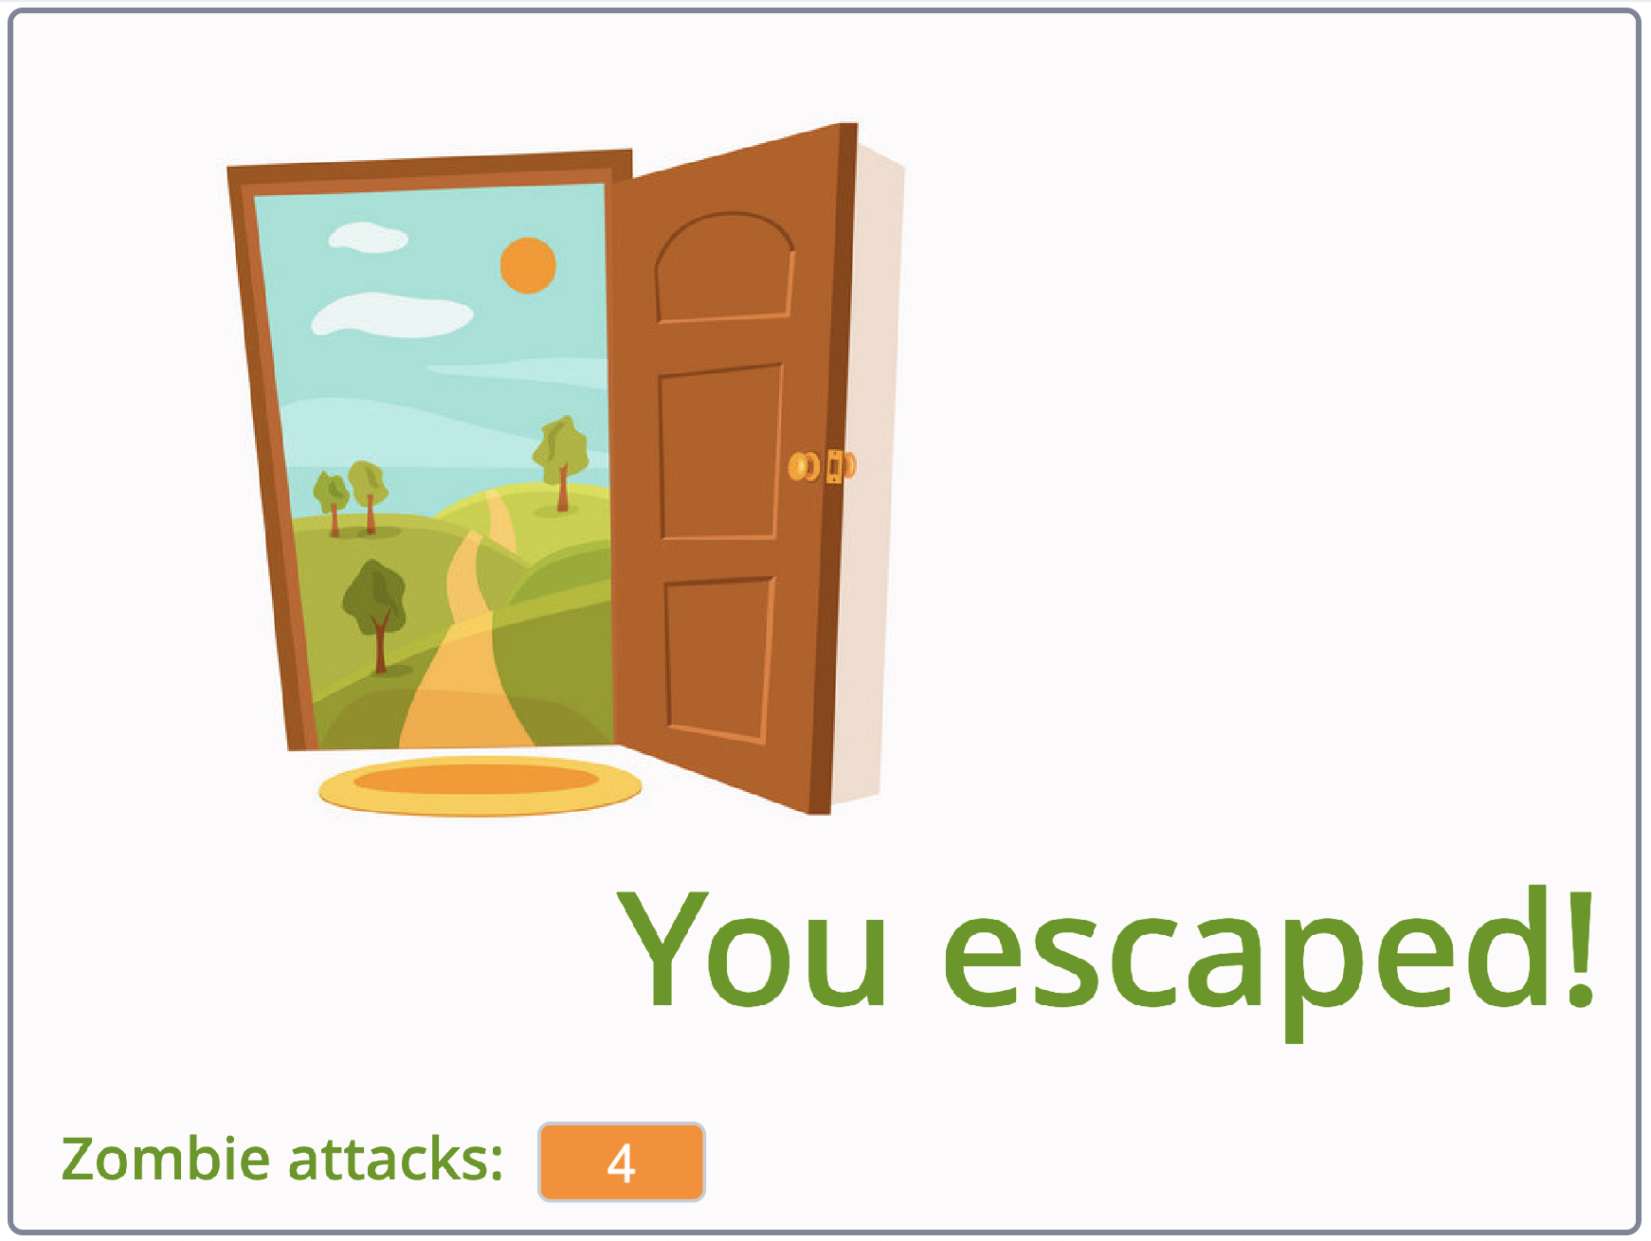
2. Click the **Green Flag** and try again. Do this several times.   
   *Your project collects training data each time you play, so it should get better each time.   
   If you try escaping several times, does it get better?  
   Can you make a perfect escape without being attacked?*

**What have you done so far?**

Hopefully your machine learning model is doing a good job of keeping you safe, by making good predictions about where zombies are lurking.

Do you think you know how it is making these predictions?

Which of your sensors do you think is the most useful and making the biggest difference? What sort of values make zombies more likely?

The final step is to check if your machine learning model agrees with you.

1. In the training tool window, click the **“< Back to project**” link.   
   Then click the “**Learn & Test**” button.
2. Click on the “**Describe your model**” button.  
   *This page will show you a picture of your machine learning model.*   
   *Read the page to understand what it means. Try putting in values for a hotel room and clicking* ***Test*** *to see how it works.*  
   A screenshot of a social media post

   Description automatically generated

**What have you done?**

The type of machine learning model you’ve trained is a “**decision tree classifier**”. The visualisation lets you see how your model makes predictions. It’s a good way to see what patterns the computer found in the training data you collected.

For example, the sensor values it learned have the biggest difference (on whether or not a zombie will be in the room) will typically be nearer the top of the tree diagram.